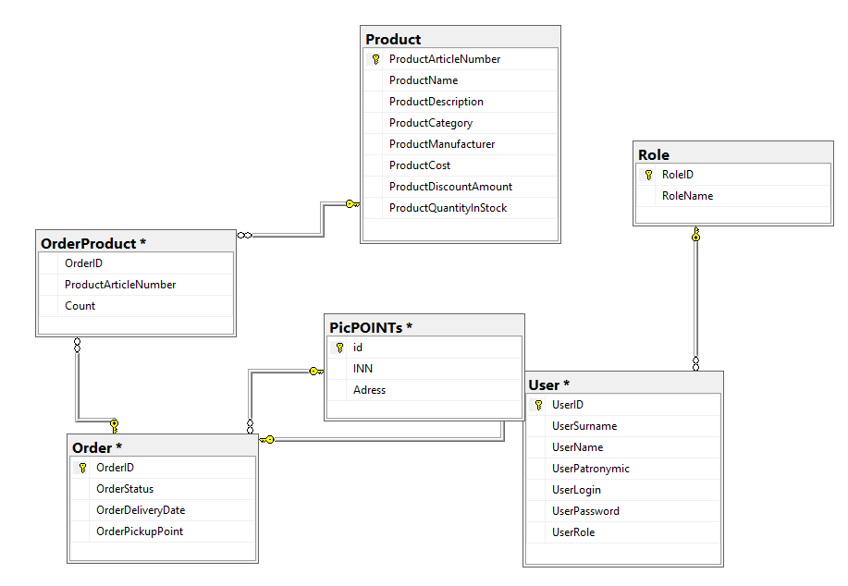

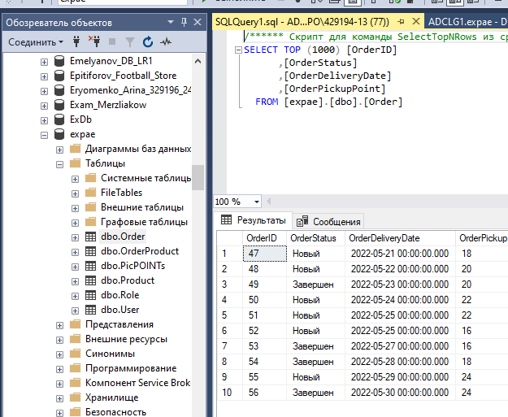

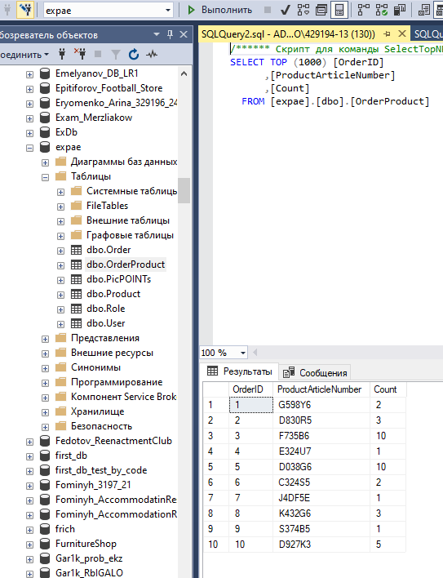

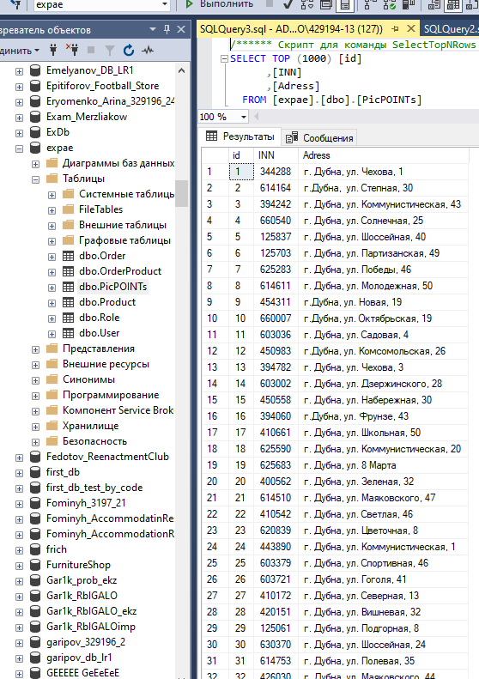

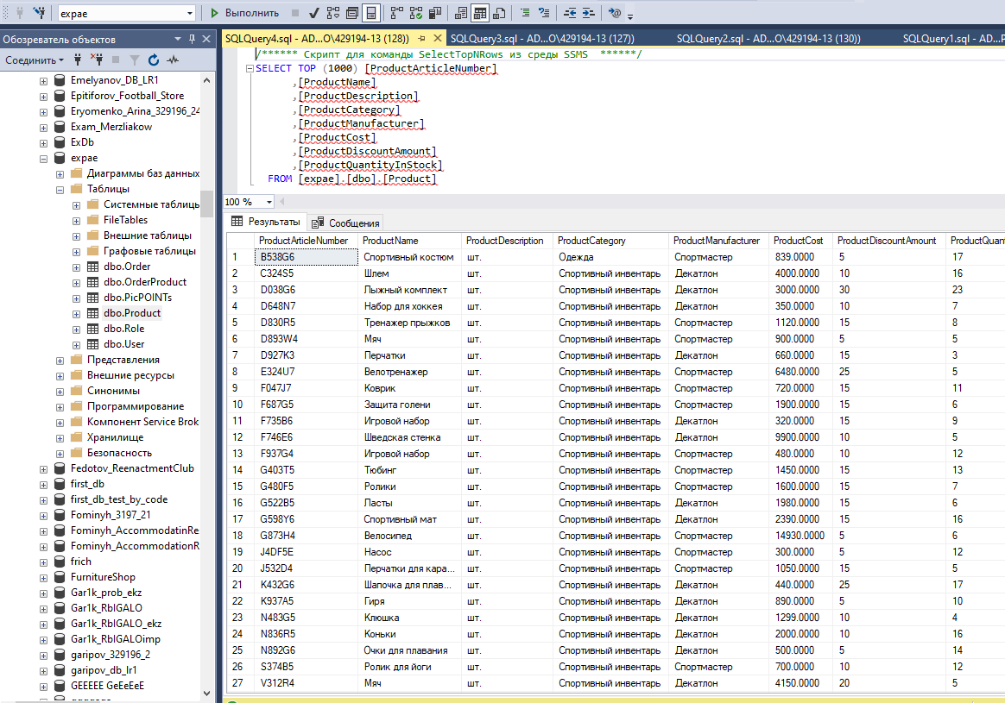

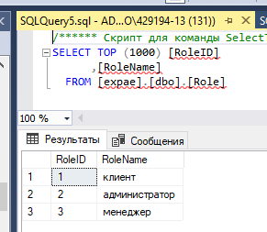

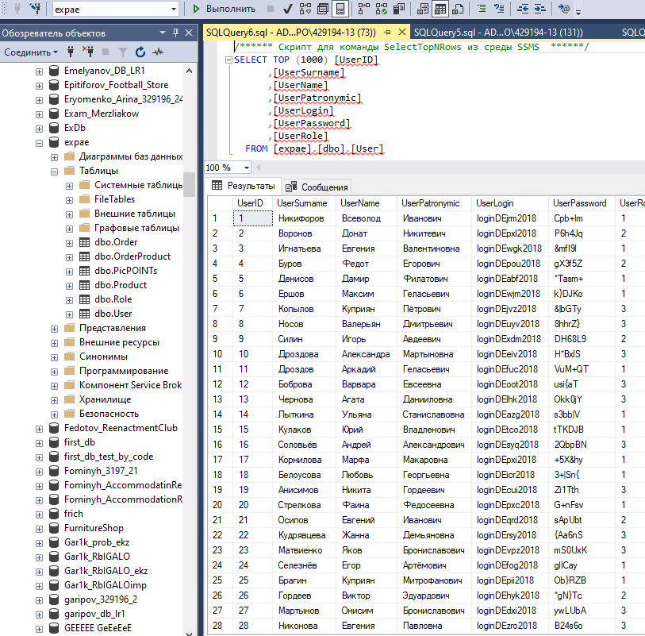

using System;

using System.Collections.Generic;

using System.ComponentModel;

using System.Data;

using System.Drawing;

using System.Linq;

using System.Text;

using System.Threading.Tasks;

using System.Windows.Forms;

namespace WindowsFormsApp1

{

public partial class trueform : Form

{

string captchaAnswer = "none";

int tryCounter = 0;

public trueform()

{

InitializeComponent();

}

private void tbLogin_TextChanged(object sender, EventArgs e)

{

if (tbLogin.Text != "" && tbPassword.Text != "" && captchaAnswer == "none")

{

btnEnter.Enabled = true;

}

else

{

btnEnter.Enabled = false;

}

}

private void generateCaptcha()

{

lbC1.Font = new Font(label1.Font, label1.Font.Style | FontStyle.Strikeout);

lbC2.Font = new Font(label1.Font, label1.Font.Style | FontStyle.Strikeout);

Random random = new Random();

int a = random.Next(10, 100);

int b = random.Next(10, 100);

lbC1.Visible = true;

lbC2.Visible = true;

tbCaptcha.Visible = true;

captchaAnswer = a.ToString() + b.ToString();

}

private void dropCaptcha()

{

captchaAnswer = "none";

tryCounter = 0;

lbC1.Visible = false;

tbCaptcha.Visible = false;

}

private void trueform_Load(object sender, EventArgs e)

{

}

private void label1_Click(object sender, EventArgs e)

{

}

private void btnEnter_Click(object sender, EventArgs e)

{

}

}

}

